PLEASE CONTACT CODE/PLANNING OFFICE BEFORE FILLING OUT FORMS
TOWN OF FARMINGTON
153 Farmington Falls Road, Farmington, ME 04938
207-778-5874

PROJECT REGISTRATION and CONTACT CHECKLIST

 | BUSINESS PROJECT#  __ __ BP __ __ |  | RESIDENTIAL PROJECT#  __ __ RP __ __ |  | HOME OCCUPATION#  __ __ HO __ __
 | New Business |  | New Construction |  | New Business
 | Expansion |  | Expansion |  | Expansion
 | Relocation |  | Relocation |  | Relocation
MAP ______ LOT ______ |  | ZONING ______ |  | TRIO ______

Applicant: _______________________ |  |  |  | Address: ____________________________ |  |  |  |  | Phone: ___________
Email: Project Location:___________________________________
Project Description: ________________________________________________________________________

________________________________________________________________________________________
________________________________________________________________________________________
________________________________________________________________________________________

________________________________________________________________________________________

CONTACTS REQUIRED:
 | Code/Planning – Zoning, setbacks, signage, ADA, etc.  J. Stevens Kaiser 778-5874 |  |  | Maine Uniform Building & Energy Code (MUBEC) – Third-Party Inspector  (See attached MUBEC Notice) |  |  |  | Assessor – New construction or razing, etc. Frank Xu 778-6530
 | Licensed Plumbing Inspector – Plumbing and septic permits.  Andrew Marble 779-4858 |  |  | Waste Water/Sewer  Joe Hartigan 778-4712  Sewer hook-up fees  Mavis Gensel 778-6538 |  |  |  | Public Works – New driveway, site distance, and road opening.  Philip Hutchins 778-2191
 | Farmington Village Corp. – Wellhead Protection, public water connection fees. 778-4777 |  |  | Fire Rescue – Chief T. D. Hardy 778-3235 |  |  |  | E-911 Addressing –  Terry Bell 778-3235 (A COPY OF THIS FORM MUST BE SUBMITTED TO FIRE RESCUE)
Other Contacts:
 |  | DIG SAFE 1-888-344-7233 |  |  |  | Town Clerk 778-6538
 |  | State Electrical Inspector 592-7903 |  |  |  | Executive Assistant 778-6538
 |  | State Fire Marshal 626-3870 / 592-3508 |  |  |  | Police Chief Kenneth Charles 778-6311
 |  | CMP (General Information) 1-800-750-4000 |  |  |  | DEP 1-800-452-1942
 |  | Franklin County Soil and Water Conservation  District 778-4767 |  |  |  | Dept. of Health and Human Services 287-3707; (INSP) 287-5671
 |  | Other:

By signing, I acknowledge that I have read and understand the above requirements.

Applicant’s Signature: ___________________________________________________________ Date: _____________

Property Owner’s Signature: ______________________________________________________ Date: _____________

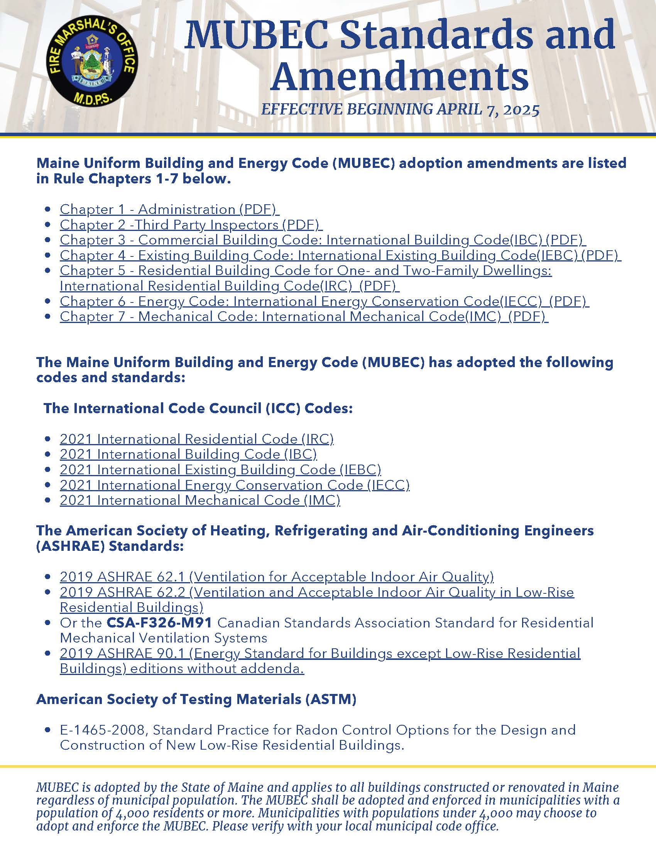
E. Dimensional Requirements:

Lots in all Zoning Districts outside the Shoreland Zoning District shall meet or exceed the following requirements:
 | General | Residential | Village | Village | Village | Village | Residential | Farm &
 | Purpose | Light | Comm. | Business | Business | Residential | District | Forest
 | District | Comm. | District | District | Historic | District |  | District
 |  |  |  |  | District (A)
Minimum lot area SF (B)
With public sewer | 40,000 | 40,000 | 40,000 | 40,000 | 450 | 15,000 | 40,000 | 40,000
Without public sewer | 60,000 | 60,000 | 50,000 | 50,000 | N/A | 25,000 | 50,000 | 50,000
Maximum residential density in OSRD (C) | 4 units per acre after subtracting 50% open space | 4 units per acre after subtracting 50% open space | N/A | N/A | N/A | 4 units per acre after subtracting 50% open space | 4 units per acre after subtracting 50% open space | 4 units per acre after subtracting 50% open space
Minimum frontage (feet) | 150 (D) | 100 (D) | 100 | 100 | 20 | 75 | 100 (D) | 150 (D)
Minimum frontage on internal road serving OSRD (E) | 75 | 75 | N/A | N/A | N/A | 75 | 75 | 75
Minimum setback (feet)
Front | 50 | 50 | 35 | 35 | (F) | 20 | 35 | 35
Side | 25 | 15 | 15 | 15 | 0 | 10 | 15 | 15
Rear | 25 | 15 | 15 | 15 | 15 | 15 | 20 | 20
Minimum front setback from edge of pavement for internal roads serving OSRD | 20 | 20 | N/A | N/A | N/A | 20 | 20 | 20
Maximum lot coverage | 75% | 60% | 70% | 70% | 99% | 50% | 40% | 50%
Building height limits | 56’ | 56’ | 56’ | 56’ | (G) | 56’ | 56’ | 56’

Height limits do not apply to towers, antennas, or agricultural silos. Side and rear setbacks shall be measured from property boundary lines. Front setbacks established above shall be measured from the Setback Starting Point as described below in the section entitled Setback Starting Point, except with regard to the front setback from internal roads serving an OSRD. Setbacks apply to all structures except signs, landscaping, fences, and parking lots. The minimum setback from property lines for driveways in all Districts shall be ten feet (10). Where abutters elect to share a single driveway on or near their common boundary line there shall be no setback required.

The performance standards, dimensional requirements, and definition specific to Open Space Residential Development (OSRD) are only applicable to those individuals or entities voluntarily choosing to submit and OSRD project application and plan to the Town of Farmington Planning Board per 11-8.11.I.4 (a) in the Town of Farmington Zoning Ordinance for OSRD approval and permit and, as such, said OSRD standards and requirements are entirely elective and self-imposed by said individuals or entities. The OSRD performance standards, dimensional requirements, and definition apply to no other types of land-use development or projects in Farmington, whether before the Planning Board or not.

(A) The Village Business Historic District is a sub-classification within the Village Business
District. Dimensional requirements in this category apply to properties with frontage in
these areas: Main Street from Anson Street to Academy Street; Broadway from High
Street to the100-year floodplain boundary of the Sandy River; and Front Street from Park
Street to Depot Street.

(B) Minimum lot area does not apply in an Open Space Residential Development. See
maximum residential density in OSRD.

(C) A density bonus may be applied as provided in the Performance Standards, Section 11-
8.11. I (8).

(D) Backlots with frontages between fifty feet (50) and these minimums may be built on if structures are set back a minimum of two hundred fifty feet (250).

(E) Minimum frontage in OSRD applies only where individual lots are created.

(F) No closer to the street than side-abutting buildings, except when a sidewalk exists, the setback shall be no closer than the building edge of said sidewalk (the edge of the sidewalk which lies farthest from the traveled way).

(G) No taller than the highest existing building in this district as of enactment of these requirements.

Please return this required form to the
Town of Farmington’s Assessing Office

Building Notification Form

MAP TRIO # DATE
_LOT_ _
_

PROPERTY OWNER PHONE#

MAILING ADDRESS TOWN ZIP CODE PROJECT LOCATION
CONTRACTOR PHONE#

Is any part of this property or project located in any of the following? Shoreland Zone Floodway Floodplain
PROJECT DESCRIPTION

**Public Sewer: YES or NO (please circle)
Number of plumbing fixtures: Presently Proposed Number of bedrooms: Presently Proposed

Estimated Start Date:

_ Estimated Completion Date:

*Please draw a sketch of the project showing dimensions and placement of building(s).*

The Town now has building setback requirements that could affect your project. Please check with the Code Enforcement Officer concerning the standard.

The above information provides accurate information concerning the project described.

SIGNATURE

DATE OF NOTIFICATION

TOWN OF FARMINGTON

Building Notification Ordinance

Section 1: Scope and Purpose:

It is the purpose of this Ordinance to require that the Town Assessor’s Office be notified of all building projects in order to allow the Town to maintain accurate records of such projects and to allow for a fair distribution of the Town’s tax burden.

Section 2: Definition:

“Building Project” is defined as any of the following activities:

1. New construction of a structure or building.

2. Addition or structural modification of any existing structure or building in excess of fourteen hundred dollars, ($1,400.00) in material costs.
3. Demolition of a structure or building.

4. Installation of a mobile home.

Section 3: Exemptions:

Normal upkeep and maintenance of existing structures and buildings, such as painting, roof shingling, repair of broken windows and doors, etc. shall not require notification.

Section 4: Procedure:

Before any building project may commence, the person, business, or corporation responsible for same shall notify the Assessor’s Office by completing and submitting the Notification Form provided by the office.

Section 5: Penalty:

This Ordinance shall be administered and enforced by the Assessor’s Office. Any person, business or corporation failing to submit the proper notification prior to commencement of the building project shall be subject to a civil penalty of one hundred dollars ($100.00).

Effective: March 14, 1989

This is a true copy of the “Building Notification Ordinance” submitted by the Town
Manager’s/Selectmen’s Office.

Leanne E. Dickey – Town Clerk
April 3, 2000

